Loading Form is an application form before the opening of this school of information systems will be raised. I made ​​it with some components that do not include standard components from VB 6. Therefore I give you all the download link for this loading can create the form.

1. aicAlphaImage to display PNG images. Download it here.
2. ARProgressBar to make cool progress bar. Download it here.

Then below this is the arrangement of each kompenen that will be used in this form. All these settings can you change your taste respectively.

|  |  |  |
| --- | --- | --- |
| **Object** | **Properties** | **Setting** |
| **Form** | Name | FrmLoading |
|  | BorderStyle | 0-None |
|  | BackColor | &H00FFC0C0& |
|  | StartUpPosition | 2-CenterScreen |
|  | ShowInTaskBar | 1-True |
| aicAlphaImage | Name | aicAlphaImage1 |
|  | ScaleMethod | 1-aiStretch |
|  | Picture | As you wish |
| ARProgressBar | Name | Bar |
|  | Border | 1-Simple |
|  | EndColor | &H0000C000& |
|  | IniColor | &H0080FF80& |
|  | UseGradient | True |
| Timer | Name | Timer1 |
|  | Interval | 30 |

And here is design of loading form

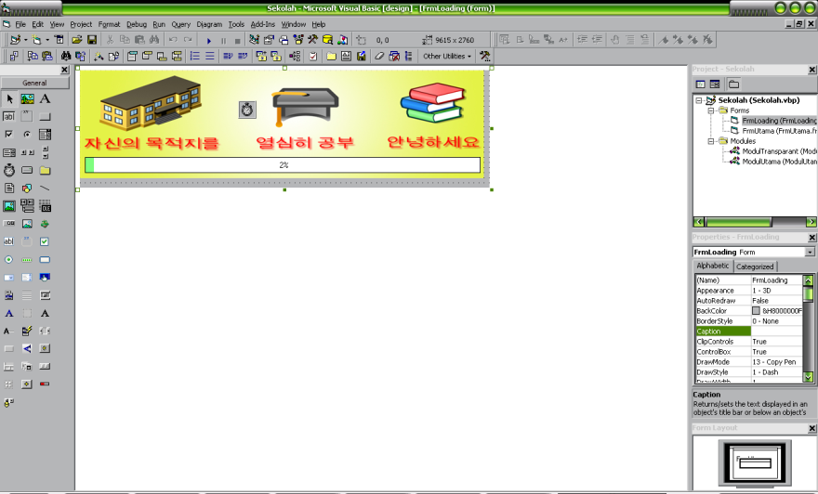

Images form when running



And the following is a source code form loading

Private Sub Form_Load()

FadeForm Me.hwnd, True

Me.Caption = "Loading..."

Bar.Value = 0

Me.Height = Me.aicAlphaImage1.Height

Me.Width = Me.aicAlphaImage1.Width

Me.Timer1.Enabled = True

End Sub

Private Sub Timer1_Timer()

If Bar.Value = 100 Then

Timer1.Enabled = False

Unload Me

FrmUtama.Show

ElseIf Bar.Value = 50 Then

Bar.CaptionForeColor = vbWhite

Bar.Value = Val(Bar.Value) + 1

Else

Bar.Value = Val(Bar.Value) + 1

End If

End Sub

**Watch and Learn**